dompdf php download

<https://github.com/dompdf/dompdf/releases>

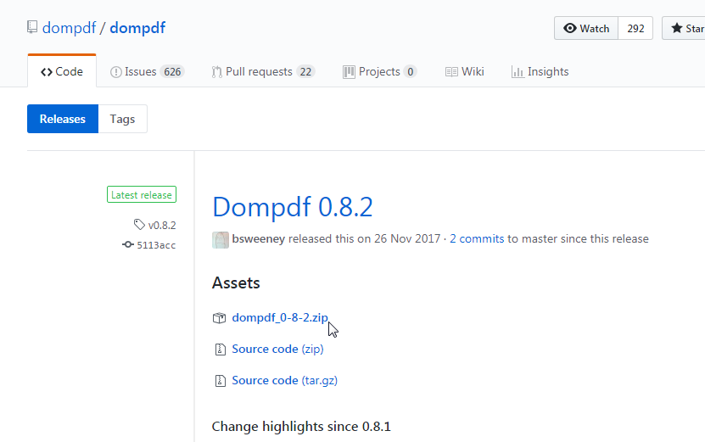

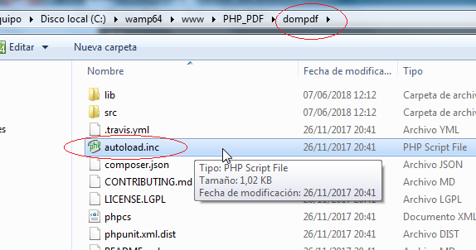

Require_once ‘dompdf/autoload.inc.pdf’:

<?php

include("checklog.php");

require_once("watchlist-controller.php");

require_once("dompdf/dompdf_config.inc.php");

ob_start();

?>

<html>...</html>

<?php

$html = ob_get_clean();

$dompdf = new DOMPDF();

$dompdf->load_html($html);

$dompdf->render();

$dompdf->stream("sample.pdf");

?>